MLOps Practical – 3
Kubeflow Pipelines Backend, Manual Execution & Scheduling
Complete Student-Friendly Theory + Hands-on Laboratory Manual
Item | Details
Course | MLOps
Unit | Model Deployment & Pipeline Orchestration
Practical | 3
Technology | Kubeflow Pipelines 2.17.0 + Kubernetes
ML Example | Iris classification + quality gate
Schedule demonstration | Every 3 minutes
Execution | KFP Backend on Kubernetes
What students will build: A complete KFP workflow that is compiled, uploaded, executed manually, and then automatically executed by a recurring scheduler.

Contents
- 1. Practical Overview
- 2. Objectives and Learning Outcomes
- 3. Prerequisites and Environment
- 4. Theory: KFP Backend
- 5. Local KFP vs Backend KFP
- 6. Architecture and Components
- 7. Pipeline Used in the Practical
- 8. Project Files and Code
- 9. Hands-on Part A: Verify Environment
- 10. Hands-on Part B: Compile Pipeline
- 11. Hands-on Part C: Start KFP Dashboard
- 12. Hands-on Part D: Upload Pipeline
- 13. Hands-on Part E: Manual Run
- 14. Hands-on Part F: Create Recurring Run
- 15. Hands-on Part G: Verify Automatic Runs
- 16. Detailed Explanation of Scheduling
- 17. Error Tracing and Troubleshooting
- 18. Observed Lab Errors and Their Resolution
- 19. Practical Result and Evidence
- 20. Viva Questions
- 21. Student Submission Checklist
- 22. Quick Command Sheet
- 23. Related Files and How to Use Them
- 24. Official References

1. Practical Overview
This practical takes the Iris ML pipeline from local development into a KFP backend. Students first understand the pipeline, compile it into an intermediate-representation YAML file, upload it to the KFP Dashboard, execute it manually, and finally configure a recurring run that automatically starts a new pipeline execution every three minutes.
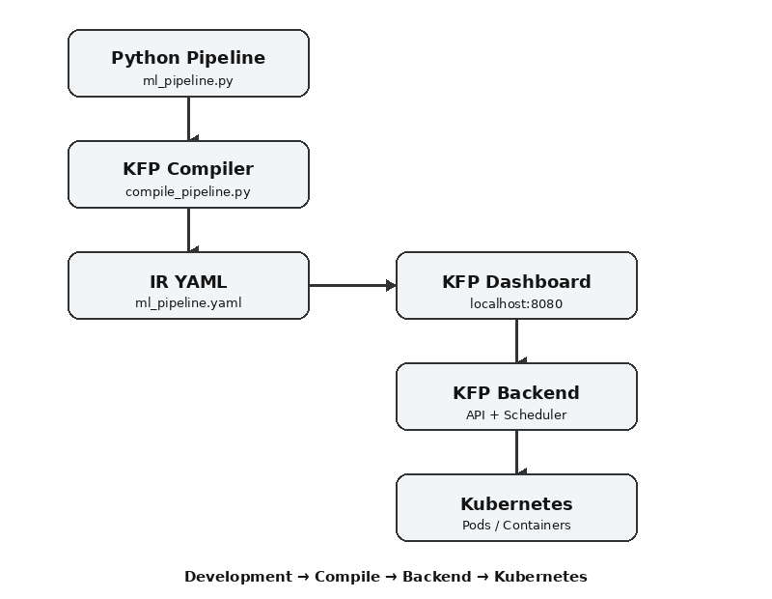
Simple idea: Python defines the workflow → the compiler creates YAML → KFP Backend manages it → Kubernetes executes the tasks → the scheduler starts new runs automatically.

2. Objectives and Learning Outcomes
Objectives:
- Understand the role of the KFP backend in MLOps.
- Verify a Kubernetes-based KFP installation.
- Compile a KFP pipeline to IR YAML.
- Upload and run a pipeline through the KFP Dashboard.
- Read task status and logs.
- Create a recurring run.
- Configure a Periodic trigger for every 3 minutes.
- Trace common UI, Kubernetes, and scheduler errors.
Learning outcomes:
- Explain KFP Backend vs local execution.
- Compile and upload a pipeline.
- Execute and monitor a pipeline.
- Configure and verify automatic scheduling.
- Identify the likely cause of a broken port-forward.
- Inspect KFP and Kubernetes logs for failures.

3. Prerequisites and Environment
Item | Lab value / purpose
Windows | Windows 10/11 host
WSL2 | Linux environment
Ubuntu | Command-line environment
Docker Desktop | Container runtime and Kubernetes integration
Kubernetes | Execution platform
kubectl | Kubernetes CLI
Python | Pipeline development
KFP SDK | Pipeline definition and compilation
KFP Backend | Pipeline management, execution and scheduling
KFP version | 2.17.0 in this lab
Python environment | Project virtual environment; previously verified with Python 3.14.4
The practical assumes Docker Desktop, WSL2, Kubernetes, and the KFP backend are already installed. Installation/reinstallation of the backend is documented in troubleshooting notes; the main focus is backend use and scheduling.

4. Theory: What is the KFP Backend?
Kubeflow Pipelines (KFP) provides a way to define ML workflows as connected components. The backend receives a compiled pipeline specification, stores and manages pipeline/run information, and coordinates execution in the Kubernetes environment.

4.1 Local execution
Python Pipeline
|
v
KFP Local Runner
|
v
Local machine
|
v
Tasks execute locally

4.2 Backend execution
Python Pipeline
|
v
KFP Compiler
|
v
ml_pipeline.yaml
|
v
KFP Backend
|
v
Kubernetes
|
v
Pods / Containers
Student definition: Local execution is mainly for testing. Backend execution adds centralized management, dashboard monitoring, run history and recurring scheduling.

5. Local KFP vs Backend KFP
Feature | Local execution | KFP Backend
Execution | Local machine | Kubernetes
Dashboard | No central dashboard | Yes
Run history | Local/testing oriented | Centralized
Recurring scheduling | Not the focus | Yes
Task orchestration | Local runner | Backend + Kubernetes
Monitoring | Terminal/local output | Dashboard + logs
Best use | Development/testing | Managed workflow orchestration

6. Architecture and Components
Component | Student-friendly role
ml-pipeline | Main KFP backend/API service
ml-pipeline-ui | Web dashboard
ml-pipeline-scheduledworkflow | Scheduling/recurring workflow support
workflow-controller | Coordinates workflow execution
metadata-grpc | Metadata service
mysql | Backend database
cache-server / cache-deployer | Pipeline cache-related services
seaweedfs | Artifact/storage-related service in this deployment
kubectl get pods -n kubeflow

7. Pipeline Used in the Practical
The Iris classification pipeline has four components:
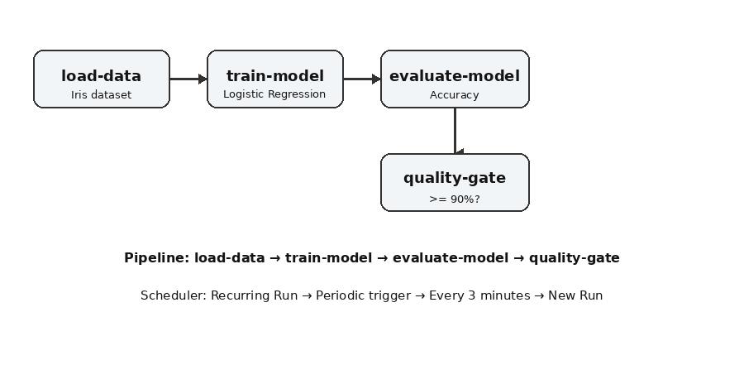
Component | What it does
load-data | Loads Iris data, performs a stratified 80/20 train/test split and returns JSON.
train-model | Trains Logistic Regression and serializes the model as base64-encoded pickle.
evaluate-model | Restores the model, predicts test data and returns accuracy.
quality-gate | Checks whether accuracy is at least 0.90; otherwise raises an error.
Observed successful execution:
Total samples: 150
Training samples: 120
Testing samples: 30
Model Accuracy: 0.9667
Model Accuracy: 96.67%
QUALITY GATE: PASS
Why use a quality gate?: It demonstrates that an ML workflow can automatically stop when a model metric fails a defined requirement.

8. Project Files and Code
File | Purpose
ml_pipeline.py | Complete pipeline definition used in this lab.
compile_pipeline.py | Compiles ml_pipeline.py into ml_pipeline.yaml.
requirements.txt | Pins KFP and Docker SDK versions used in the environment.
verify_backend.sh | Checks Kubernetes nodes, KFP pods, services and workflows.
start_kfp_ui.sh | Starts the KFP UI port-forward.
.gitignore | Ignores virtual environments, local outputs and logs.
ml_pipeline.yaml.README | Explains why the real compiled YAML must be generated locally.

8.1 Complete ml_pipeline.py
from kfp import dsl
from kfp import local
@dsl.component(
base_image="python:3.11",
packages_to_install=["scikit-learn"]
)
def load_data() -> str:
from sklearn.datasets import load_iris
from sklearn.model_selection import train_test_split
import json
iris = load_iris()
X_train, X_test, y_train, y_test = train_test_split(
iris.data,
iris.target,
test_size=0.2,
random_state=42,
stratify=iris.target
)
print(f"Total samples: {len(iris.data)}")
print(f"Training samples: {len(X_train)}")
print(f"Testing samples: {len(X_test)}")
data = {
"X_train": X_train.tolist(),
"X_test": X_test.tolist(),
"y_train": y_train.tolist(),
"y_test": y_test.tolist()
}
return json.dumps(data)
@dsl.component(
base_image="python:3.11",
packages_to_install=["scikit-learn"]
)
def train_model(data_json: str) -> str:
import json
import pickle
import base64
from sklearn.linear_model import LogisticRegression
data = json.loads(data_json)
X_train = data["X_train"]
y_train = data["y_train"]
model = LogisticRegression(max_iter=200)
model.fit(X_train, y_train)
model_bytes = pickle.dumps(model)
model_encoded = base64.b64encode(model_bytes).decode("utf-8")
print("Model training completed.")
return model_encoded
@dsl.component(
base_image="python:3.11",
packages_to_install=["scikit-learn"]
)
def evaluate_model(
model_encoded: str,
data_json: str
) -> float:
import json
import pickle
import base64
from sklearn.metrics import accuracy_score
data = json.loads(data_json)
X_test = data["X_test"]
y_test = data["y_test"]
model_bytes = base64.b64decode(model_encoded)
model = pickle.loads(model_bytes)
predictions = model.predict(X_test)
accuracy = accuracy_score(y_test, predictions)
print(f"Model Accuracy: {accuracy:.4f}")
print(f"Model Accuracy: {accuracy * 100:.2f}%")
return accuracy
@dsl.component
def quality_gate(
accuracy: float,
threshold: float = 0.90
):
print(f"Required accuracy: {threshold * 100:.2f}%")
print(f"Actual accuracy: {accuracy * 100:.2f}%")
if accuracy >= threshold:
print("QUALITY GATE: PASS")
else:
raise RuntimeError(
f"QUALITY GATE: FAIL - "
f"Accuracy {accuracy:.4f} is below "
f"required threshold {threshold:.4f}"
)
@dsl.pipeline
def ml_pipeline():
data_task = load_data()
train_task = train_model(
data_json=data_task.output
)
evaluate_task = evaluate_model(
model_encoded=train_task.output,
data_json=data_task.output
)
quality_gate(
accuracy=evaluate_task.output,
threshold=0.90
)
if __name__ == "__main__":
local.init(
runner=local.SubprocessRunner()
)
ml_pipeline()

8.2 Complete compile_pipeline.py
from kfp import compiler
from ml_pipeline import ml_pipeline
compiler.Compiler().compile(
pipeline_func=ml_pipeline,
package_path="ml_pipeline.yaml"
)
print("Pipeline compiled successfully!")
print("Generated: ml_pipeline.yaml")

8.3 requirements.txt
kfp==2.17.0
docker==7.2.0

8.4 verify_backend.sh
#!/usr/bin/env bash
set -e
echo "=== Kubernetes ==="
kubectl cluster-info
kubectl get nodes
echo
echo "=== KFP Pods ==="
kubectl get pods -n kubeflow
echo
echo "=== KFP Services ==="
kubectl get svc -n kubeflow
echo
echo "=== KFP Workflows ==="
kubectl get workflows -n kubeflow

8.5 start_kfp_ui.sh
#!/usr/bin/env bash
echo "Starting KFP Dashboard port-forward..."
echo "Keep this terminal open while using the UI."
kubectl port-forward -n kubeflow svc/ml-pipeline-ui 8080:80
Important about ml_pipeline.yaml: The real uploadable YAML is generated by KFP 2.17.0. It should not be fabricated or manually typed. Run python compile_pipeline.py in the same KFP environment used for the lab.

9. Hands-on Part A: Verify the Environment
Open Ubuntu/WSL and activate the project environment.
cd ~/kubeflow-mlops/ci-kfp-demo
source ../.venv/bin/activate
python --version
Verify Kubernetes:
kubectl cluster-info
kubectl get nodes
Expected: the control-plane should be reachable and the node should be Ready.
Verify KFP:
kubectl get pods -n kubeflow
Most KFP pods should show Running/Ready. If not, stop here and troubleshoot the first failing pod before continuing.

10. Hands-on Part B: Compile the Pipeline
cd ~/kubeflow-mlops/ci-kfp-demo
python compile_pipeline.py
Expected:
Pipeline compiled successfully!
Generated: ml_pipeline.yaml
Check the generated file:
ls -lh ml_pipeline.yaml
head -30 ml_pipeline.yaml
Concept: The YAML is the compiled pipeline specification. It is not the Python source code.

11. Hands-on Part C: Start KFP Dashboard
Open a dedicated WSL terminal and keep it running:
kubectl port-forward -n kubeflow svc/ml-pipeline-ui 8080:80
Expected:
Forwarding from 127.0.0.1:8080 -> 3000
Forwarding from [::1]:8080 -> 3000
Open: http://localhost:8080
Very important: The port-forward is only the local connection to the UI. If it stops, the browser may show 'failed to retrieve run' even when the backend itself is healthy.

12. Hands-on Part D: Upload the Pipeline
- Open Pipelines.
- Choose Upload pipeline.
- Select ml_pipeline.yaml.
- Use pipeline name: Iris ML Quality Gate Pipeline.
- Verify the pipeline graph.
- Confirm the uploaded pipeline version is visible.
load-data → train-model → evaluate-model → quality-gate

13. Hands-on Part E: Manual Run
- Open Runs.
- Click Create run.
- Select Iris ML Quality Gate Pipeline.
- Select the uploaded pipeline version.
- Use the Default experiment.
- Name the run, for example Iris Manual Run 1.
- Start the run.
- Open the run and monitor each component.
load-data ✓
train-model ✓
evaluate-model ✓
quality-gate ✓
Overall: Succeeded
Open component logs to see data counts, training messages, accuracy and quality-gate result.
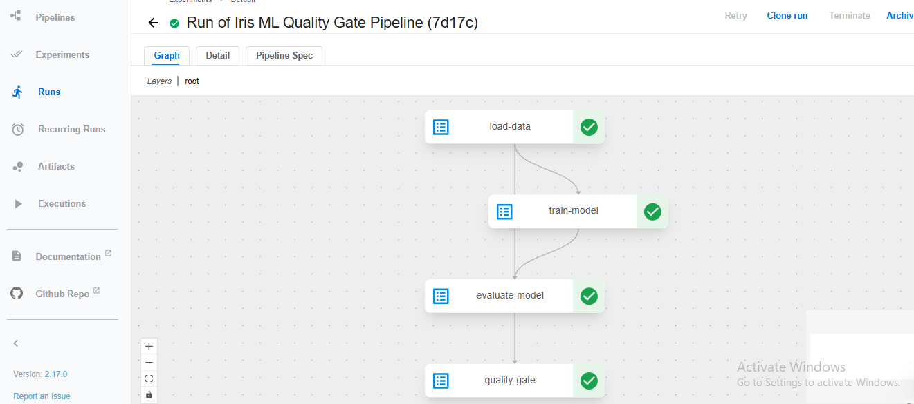

14. Hands-on Part F: Create a Recurring Run
Open Recurring Runs and click + Create recurring run.
Field | Value used in this lab
Pipeline | Iris ML Quality Gate Pipeline
Pipeline Version | Successful uploaded version
Recurring run name | Iris 3-Minute Scheduled Run
Description | Automatically execute the Iris ML pipeline on a recurring schedule.
Experiment | Default
Run Type | Recurring
Trigger type | Periodic
Maximum concurrent runs | 10
Has start date | Unchecked
Has end date | Unchecked
Catchup | Unchecked
Run every | 3 Minutes
Custom Pipeline Root | Unchecked
Run parameters | None
Click Start only after checking all settings.
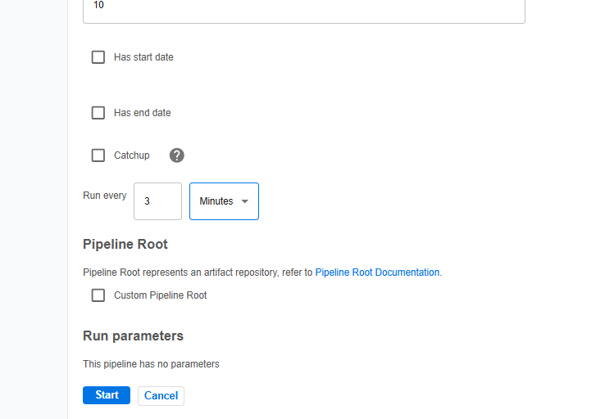

15. Hands-on Part G: Verify Automatic Runs
After creating the recurring run, open its details.
Enabled: Yes
Trigger: Every 3 minutes
Max. concurrent runs: 10
Catchup: false
Then open Runs and refresh after the next interval.
Example:
6:02:58 PM -> scheduled Run 1 -> Succeeded
6:05:59 PM -> scheduled Run 2 -> Running
next -> scheduled Run 3
...
The completed lab showed this pattern: a previous scheduled run succeeded and a new run appeared about three minutes later.
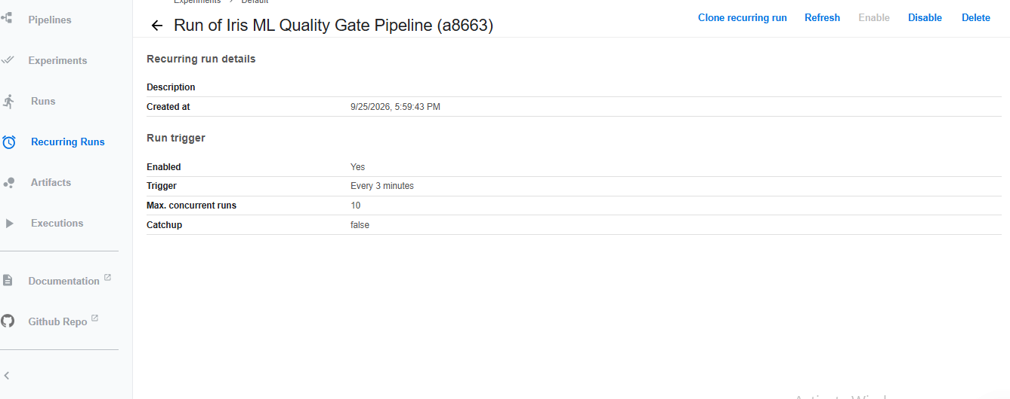
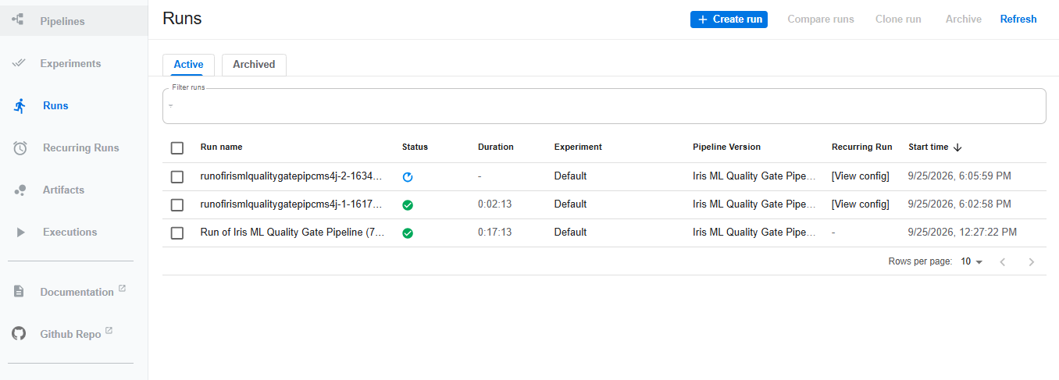

16. Detailed Explanation of Scheduling
One-off:
User -> Start -> One pipeline run
Recurring:
Recurring configuration
|
v
Periodic trigger
|
+--> Run 1
+--> Run 2
+--> Run 3
+--> ...

16.1 Periodic vs Cron
Trigger | Meaning | Example
Periodic | Fixed interval | Every 3 minutes
Cron | Calendar-style schedule | Specific time/day pattern

16.2 Catchup
Catchup controls how missed scheduled executions are treated after scheduler downtime. For this classroom demonstration, Catchup was disabled so that a backlog of missed demonstration runs would not be the focus.

16.3 Maximum concurrent runs
If a pipeline takes longer than the scheduling interval, multiple runs may overlap. Maximum concurrent runs places a limit on simultaneous executions for the recurring configuration.

17. Error Tracing and Troubleshooting
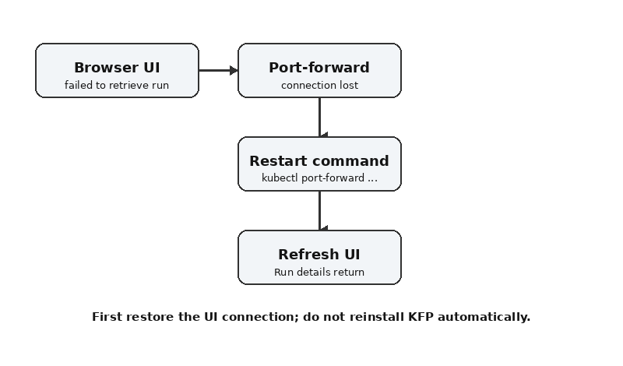

17.1 UI error: 'Error: failed to retrieve run'
Observed during the lab after the system had been idle for several hours. The immediate cause was the local kubectl port-forward connection terminating.
kubectl port-forward -n kubeflow svc/ml-pipeline-ui 8080:80
Then refresh http://localhost:8080. Do not reinstall KFP just because the browser cannot retrieve a run; first restore the UI port-forward.

17.2 Terminal error: 'lost connection to pod'
This appeared in the port-forward terminal. It means the forwarding session lost its connection to the UI pod.
kubectl port-forward -n kubeflow svc/ml-pipeline-ui 8080:80
Restarting the port-forward restored the dashboard.

17.3 UI metadata-store warning
During an earlier manual-run attempt, the UI temporarily displayed a metadata-store retrieval error while the workflow still progressed. After the backend was cleanly rebuilt and the services became healthy, the manual run completed successfully. The lesson is to check actual workflow/pod status before assuming a transient UI banner means pipeline failure.
kubectl get pods -n kubeflow
kubectl get workflows -n kubeflow

17.4 Pipeline run fails
KFP Dashboard
|
+--> Runs
|
+--> failed run
|
+--> failed task
|
+--> Logs
Find the first failed task and inspect its logs before investigating downstream tasks.

17.5 Scheduler creates no runs
kubectl get pods -n kubeflow
kubectl logs deployment/ml-pipeline-scheduledworkflow -n kubeflow
kubectl logs deployment/workflow-controller -n kubeflow
Also check that the recurring configuration is Enabled = Yes and the trigger is configured as intended.

17.6 KFP pods show ImagePullBackOff
This is an image-pull problem, not a pipeline-code problem. Inspect the pod events:
kubectl get pods -n kubeflow
kubectl describe pod <pod-name> -n kubeflow
Look at the Events section for the actual image-pull message.

17.7 Recurring run is disabled
Open Recurring Runs, open the configuration, and use Enable. Verify Enabled = Yes afterward.

17.8 Too many overlapping runs
If execution takes longer than the schedule interval, runs can overlap. Review execution duration, schedule interval and maximum concurrent runs. The three-minute interval is intentionally short for classroom demonstration.

18. Observed Lab Errors and Their Resolution
Observed symptom | Diagnosis | Action
UI failed to retrieve run after ~3 hours | Port-forward session lost | Restart kubectl port-forward and refresh
Terminal: lost connection to pod | Port-forward connection ended | Restart port-forward
Transient metadata-store UI banner | Temporary UI/backend metadata interaction issue | Check pod/workflow status; do not assume pipeline failure
Scheduler client out-of-cluster kubeconfig warning | Backend tried out-of-cluster configuration first | In-cluster configuration followed; not a blocker
Workflow tasks completed successfully | Backend execution healthy | Verify green task status and logs
Recurring runs appeared every ~3 minutes | Scheduler working | Verify automatic executions in Runs

19. Practical Result and Evidence
The practical is successful when:
- Kubernetes node is Ready.
- KFP pods are healthy.
- ml_pipeline.py compiles successfully.
- ml_pipeline.yaml is generated.
- Pipeline is visible in the Dashboard.
- Manual run succeeds.
- Quality gate reports PASS.
- Recurring run shows Enabled = Yes.
- Trigger shows Every 3 minutes.
- New runs appear automatically.
The completed lab produced a successful manual run and scheduled runs at approximately three-minute intervals.

20. Viva Questions
Q. What is KFP?
A. A platform for defining and executing ML workflows.
Q. Why compile a pipeline?
A. To convert the Python pipeline definition into a specification the backend can execute.
Q. What is the KFP backend?
A. The server-side system that manages pipeline definitions, runs and orchestration functions.
Q. What is a pipeline run?
A. One execution of a pipeline.
Q. What is a recurring run?
A. A configuration that repeatedly creates pipeline runs according to a trigger.
Q. What is a Periodic trigger?
A. A fixed-interval trigger such as every 3 minutes.
Q. What is a Cron trigger?
A. A trigger based on Cron scheduling rules.
Q. Why Kubernetes?
A. It provides infrastructure for containerized and orchestrated task execution.
Q. Why Docker?
A. It packages code and dependencies into reproducible execution environments.
Q. What is Catchup?
A. A scheduling setting affecting missed scheduled executions.
Q. What is maximum concurrent runs?
A. A limit on simultaneous executions for the recurring configuration.
Q. Why did the UI fail after several hours?
A. The local port-forward session ended; the backend could still be running.
Q. How do you trace a failed pipeline?
A. Find the first failed task and inspect its logs, then inspect Kubernetes workflow/pod state if needed.
Q. Scheduling vs orchestration?
A. Scheduling determines when a workflow is triggered; orchestration coordinates tasks, dependencies and execution.

21. Student Submission Checklist
☐ kubectl get nodes screenshot
☐ kubectl get pods -n kubeflow screenshot
☐ Successful compilation screenshot
☐ Pipeline graph screenshot
☐ Successful manual run screenshot
☐ Evaluate-model log screenshot
☐ Recurring Run configuration screenshot
☐ Recurring Run details showing Enabled = Yes and Every 3 minutes
☐ Runs page showing at least one scheduled run
☐ Short explanation of local vs backend execution
☐ Short explanation of scheduling vs orchestration
☐ One troubleshooting example

22. Quick Command Sheet
# Activate environment
cd ~/kubeflow-mlops/ci-kfp-demo
source ../.venv/bin/activate
# Kubernetes
kubectl cluster-info
kubectl get nodes
kubectl get pods -n kubeflow
kubectl get svc -n kubeflow
# Compile
python compile_pipeline.py
ls -lh ml_pipeline.yaml
# Start KFP UI
kubectl port-forward -n kubeflow svc/ml-pipeline-ui 8080:80
# Workflows
kubectl get workflows -n kubeflow
# Scheduler troubleshooting
kubectl logs deployment/ml-pipeline-scheduledworkflow -n kubeflow
kubectl logs deployment/workflow-controller -n kubeflow
# Dashboard
http://localhost:8080

23. Related Files and How to Use Them
- code/ml_pipeline.py — complete pipeline source.
- code/compile_pipeline.py — generates the real ml_pipeline.yaml.
- code/requirements.txt — Python dependency versions.
- code/verify_backend.sh — backend verification commands.
- code/start_kfp_ui.sh — starts UI port-forward.
- code/ml_pipeline.yaml.README — explanation of generated YAML.
- diagrams/ — architecture, pipeline/scheduler and error-tracing diagrams.
- screenshots/ — selected evidence from the completed lab.
- README.txt — bundle overview.
Important: The bundle deliberately does not contain a fabricated ml_pipeline.yaml. The real YAML must be generated by KFP 2.17.0 from ml_pipeline.py. This avoids giving students a YAML file that looks valid but cannot be trusted as the exact compiled artifact.

24. Official References
- Kubeflow Pipelines Overview: https://www.kubeflow.org/docs/components/pipelines/overview/
- KFP Installation: https://www.kubeflow.org/docs/components/pipelines/operator-guides/installation/
- Run a Pipeline: https://www.kubeflow.org/docs/components/pipelines/user-guides/core-functions/run-a-pipeline/
- Run and Recurring Run: https://www.kubeflow.org/docs/components/pipelines/concepts/run/
- Run Trigger: https://www.kubeflow.org/docs/components/pipelines/concepts/run-trigger/
- Compile a Pipeline: https://www.kubeflow.org/docs/components/pipelines/user-guides/core-functions/compile-a-pipeline/
- Execute KFP Pipelines Locally: https://www.kubeflow.org/docs/components/pipelines/user-guides/core-functions/execute-kfp-pipelines-locally/

